**1、10月31日作业**

1、

#include<stdio.h>

#include<math.h>

main()

{

int n, i, k,flag=0;

printf("请输入n:");

scanf("%d",&n);

k = (int)sqrt((double)n);

for (i = 2; (i <= k)&&(flag==0); i++)

{

if (n % i == 0) flag=1;

}

if (flag)

{

printf("n的因子有:");

for (i = 2; i < n; i++)

{

if (n % i == 0)

printf("%d ", i);

}

printf("\n");

}

else printf("%d是素数",n);

}

3、

#include<stdio.h>

#include<math.h>

main()

{

double x, k = 1.0, s = 1.0, s0, t = 1.0, u = 1.0;

int n = 1;

printf("请输入x:");

scanf("%lf", &x);

do {

k *= n;

u *= (0.5 - n + 1) * x;

t = u/k;

s0 = s;

s += t;

n++;

} while (fabs(s - s0) > 1e-6);

printf("s=%lf", s);

}

4、

#include<stdio.h>

main()

{

int n, i;

double x, k, t, t1 = 1.0, t2 = 2.0, s = 1.0;

printf("请输入n:");

scanf("%d",&n);

if (n == 1) printf("s%d=%lf",n,s);

else

{

i = 1;

while (i < n)

{

x = t2 / t1;

s += x;

k = t1; t1 = t2; t2 = t2 + k;

i++;

}

printf("s%d=%lf\n", n, s);

}

}

7、

#include<stdio.h>

#include<math.h>

main()

{

int i, n=0, m=0;

double x, fx, s0=0.0, s1=0.0, s2=0.0;

printf("请输入30个实数：");

for (i = 1; i <= 30; i++)

{

scanf("%lf",&x);

fx = fabs(x);

s0 += fx;

if (x > 0)

{

m++;

s1 += x;

}

if (x < 0)

{

n++;

s2 += x;

}

}

printf("正数之和为%lf\n负数之和为%lf\n绝对值之和为%lf\n正数有%d\n负数有%d\n",s1,s2,s0,m,n);

}

10、

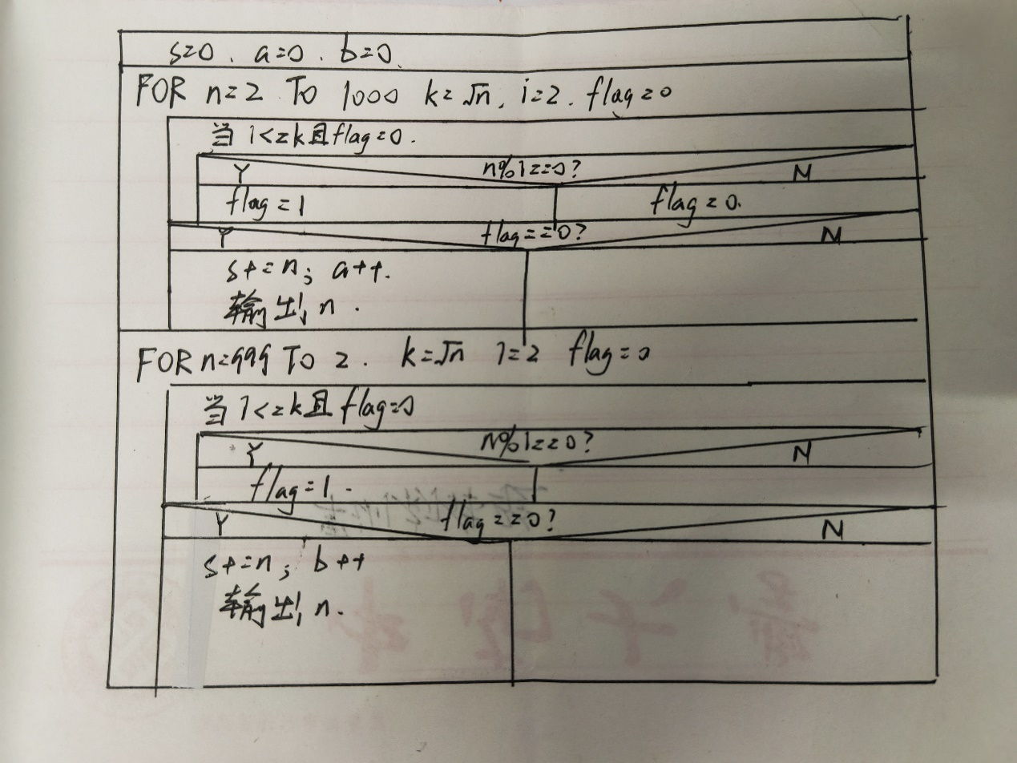

#include<stdio.h>

#include<math.h>

main()

{

int s=0, i, n, k, flag, a=0, b=0;

/*首先求出1000以内最小的10个素数*/

printf("最小素数：");

for (n = 2; (n <= 1000)&&(a<10); n++)

{

k = (int)sqrt((double)n);

i = 2; flag = 0;

while ((i <= k) && (flag == 0))

{

if (n % i == 0) flag = 1;//判断是否是素数，否则flag置1退出循环

i++;

}

if (flag == 0)

{

s += n;

a++;

printf("%d ",n);

}

}

printf("\n");

/*其次求出1000以内最大的10个素数*/

printf("最大素数：");

for (n = 999; (n >=2) && (b < 10); n--)

{

k = (int)sqrt((double)n);

i = 2; flag = 0;

while ((i <= k) && (flag == 0))

{

if (n % i == 0) flag = 1;//判断是否是素数，否则flag置1退出循环

i++;

}

if (flag == 0)

{

s += n;

b++;

printf("%d ", n);

}

}

printf("\n");

printf("素数之和：%d\n",s);//输出20个素数之和

/*处理范围内素数不足10个和有重复的情况*/

if (a < 10) printf("范围内的素数小于10个！\n");

if ((a+b) < 20) printf("最大最小素数有重复！\n");

}

11、

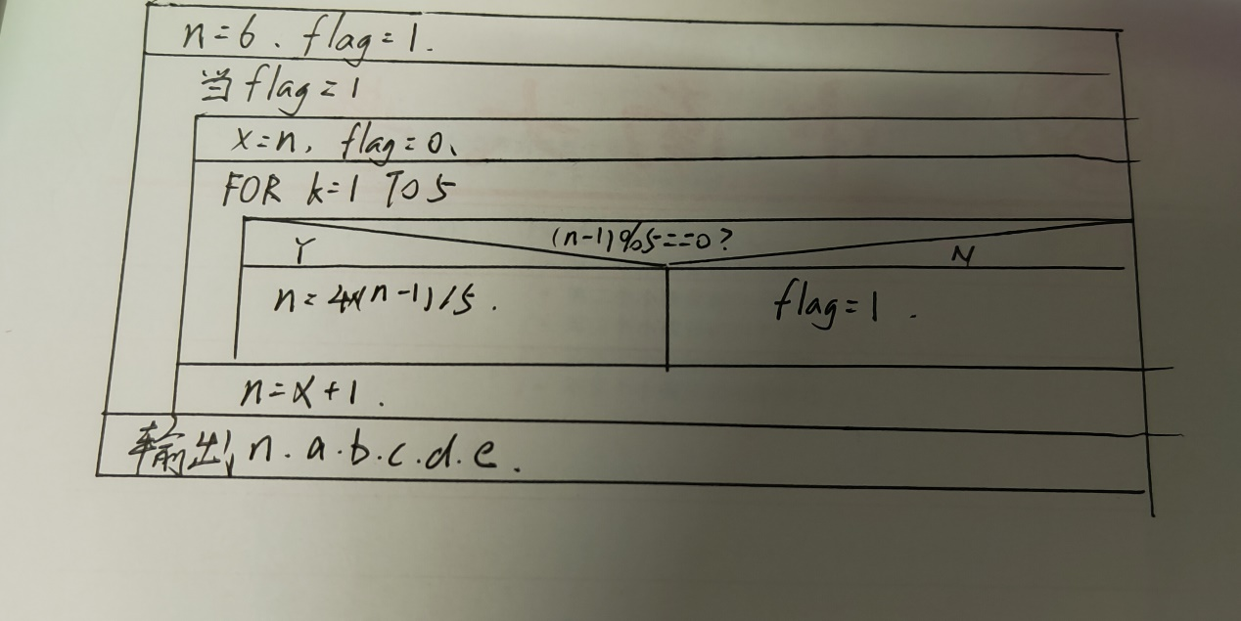

#include<stdio.h>

main()

{

int n, x, k, a, b, c, d, e, flag;

n = 6;//试探初值

flag = 1;

while (flag)

{

x = n;//保留试探值

flag = 0;

for (k = 1; k <= 5 && flag == 0; k++)//分配5次

{

if ((n - 1) % 5 == 0)

n = 4 * (n - 1) / 5;//判断是否符合条件，是则计算余下苹果

else flag = 1;

}

n = x + 1;

}

printf("原来至少有%d个苹果\n",x);

/*计算ABCDE分别得到多少苹果*/

a = (x - 1) / 5;

b = (4 * a - 1) / 5;

c = (4 * b - 1) / 5;

d = (4 * c - 1) / 5;

e = (4 * d - 1) / 5;

printf("A得到%d个苹果\n", a);

printf("B得到%d个苹果\n", b);

printf("C得到%d个苹果\n", c);

printf("D得到%d个苹果\n", d);

printf("E得到%d个苹果\n", e);

}

12、

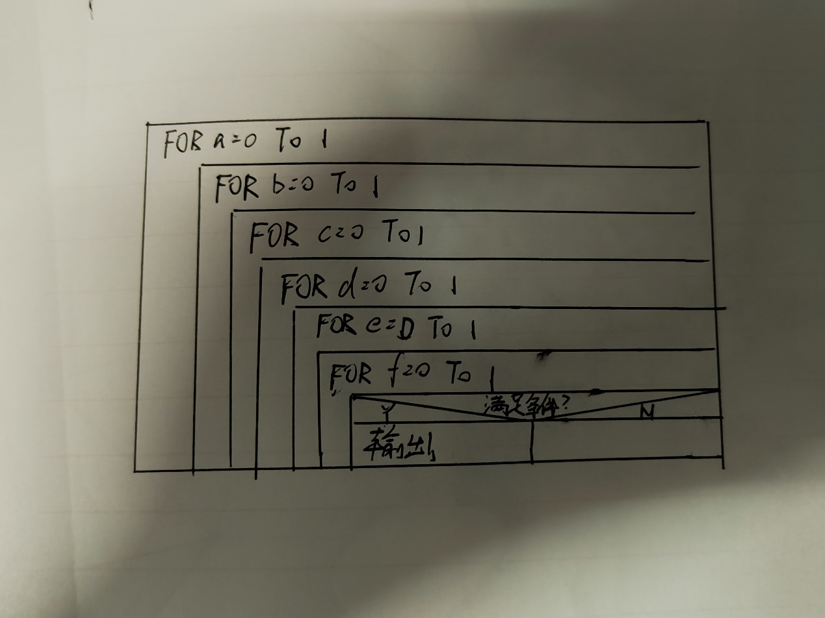

#include<stdio.h>

main()

{

int a, b, c, d, e,f;

/*对ABCDEF所有的出行情况进行枚举*/

for(a = 0; a <= 1; a++) //用1和0来表示五个人是否去

for (b = 0; b <= 1; b++)

for (c = 0; c <= 1; c++)

for (d = 0; d <= 1; d++)

for (e = 0; e <= 1; e++)

for (f = 0; f <= 1; f++)

/*满足6个条件的便可输出*/

if ((c + b == 0 || c) && c + d == 1 && ((d + e == 0) || (d + e == 2)) && a + b + f == 2 && c + f != 2 && e + f >= 2)

{

/*根据最后abcdef的值判断是否输出“不”*/

printf("A%s去\n", a ? "" : "不");

printf("B%s去\n", b ? "" : "不");

printf("C%s去\n", c ? "" : "不");

printf("D%s去\n", d ? "" : "不");

printf("E%s去\n", e ? "" : "不");

printf("F%s去\n", f ? "" : "不");

}

}